A PROJECT REPORT

Submitted by

**SHREY GADHIYA**

**229780307016**

In partial fulfilment for the award ofthe degree of

Diploma Engineering

Computer Engineering

Asiatic Institute of Science Technology - Jamvadi, Gondal



Gujarat Technological University,

Ahmedabad August, 2023

Date:



Asiatic Institute of Science Technology

Jamvadi, Taluka: Gondal, District: Rajkot

## CERTIFICATE

This is to certify that the project report submitted along with the project entitled **DODGE CHALLNGER DEMON** has been carried out by **SHREY GADHIYA**-**229780307016** under my guidance in partial fulfilment of the degree of Diploma Engineering in Computer Engineering, 3 rdSemester of Gujarat Technological

University, Ahmedabad during the academic year 2022-23.

Signature of HOD

**PROF.MEGHA GOPIYANI**

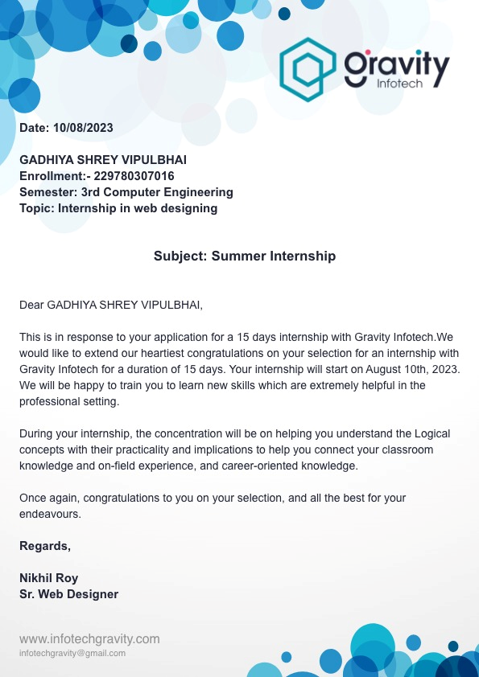

# 

Asiatic Institute of Science Technology Jamvadi, Taluka: Gondal, District: Rajkot

## DECLARATION

We hereby declare that the Internship / Project report submitted along with the Internship / Project entitled **DODGE CHALLNGER DEMON** submitted in partial fulfillment for the degree of Diploma of Engineering in Computer Engineering to Gujarat Technological University, Ahmedabad, is a bonafide record of original project work carried out by me at **GRAVITY INFOTECH** under the follow supervision of **NIKHIL ROY** and that no part of this report has been directly copied from any students' reports or taken from any other source, without providing due reference.

Name of the Student Sign of Student

### SHREYGADHIYA **_____________________**

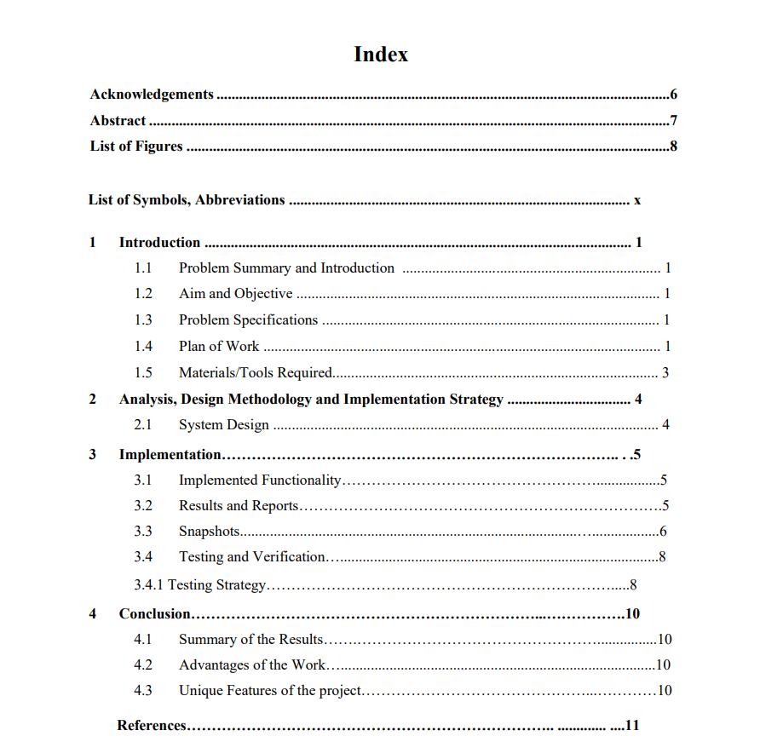

### **Acknowledgements**

It is indeed a great pleasure to express our thanks and gratitude to all those who helped us. No serious and lasting achievement or success one can ever achieve without the help of friendly guidance and co-operation of so many people involved in the work.

We are very thankful to our guide **Prof. MEGHA GOPIYANI**, the person who makes us to the right steps during this project work. We express our deep sense of gratitude to for his guidance, suggestions and expertise at every stage. Apart from that his valuable and expertise suggestion during documentation of our report indeed help us a lot.

Thanks to our friends and colleagues who have been a source of inspiration and motivation that helped to us during our research work. We would heartily thankful to head of our department **Prof. MEGHA GOPIYANI** give us an opportunity to work over this topic and for their end-less and great support. And to all other people who directly or indirectly supported and help us to fulfill our task.

And at last but not least, we would be grateful towards our parents and friends who had supported a lot and provided inspiration and motivation to go ahead in this area.

**SHREY GADHIYA**

**(229780307016)**

## **Abstract**

**DODGE CHALLNGER DEMON**

**1. Dodge Challenger Demon:** A legend in the world of American muscle cars.

**2. Unrivaled Power:** Packs an astonishing 840 horsepower.

**3. Supercharged V8 Engine:** Features a 6.2-liter HEMI V8 engine.

**4. Record-Breaking Acceleration:** Can go from 0 to 60 mph in just 2.3 seconds**.**

**5. Quarter-Mile Dominance:** Sets records with a quarter-mile time of 9.65 seconds.

**6. Limited Production:** Produced in limited numbers to maintain exclusivity.

**7. Widebody Design:** Offers a menacing and aggressive appearance.

**8. Air-Grabber Hood:** Features a massive hood scoop for improved airflow.

**9. Drag-Strip Ready:** Designed for drag racing with line-lock and transbrake.

**10. Demon Crate:** Includes race essentials like skinny front wheels and tools**.**

**11. Street-Legal Beast:** Surprisingly, it's street-legal for everyday driving.

**12. Demon Logo:** Recognizable demon head logo on fenders and inside.

**13. Torque Reserve:** Enhances launch control by managing boost.

**14. High-Performance** Suspension: Ensures superior handling and grip**.**

**15. SRT Tuning:** Fine-tuned by Dodge's Street and Racing Technology division.

**16. Customizable Interior:** Offers various trims and options for personalization.

**17. Demon Authentication Package:** Provides exclusive owner experience**.**

**18. Monster Brakes:** Equipped with massive Brembo brakes for stopping power.

**19. Race Cooldown:** After a race, cools the supercharger for the next run**.**

**20. Luxury Features:** Despite its power, it doesn't skimp on comfort.

**21. Iconic Retro Styling:** Stays true to the classic Challenger design**.**

**22. Limited Edition Colors:** Available in unique and striking paint options**.**

**23. Collector's Item:** Often sought after by enthusiasts and collectors.

**24. Exhaust Note:** Boasts an unmistakable, thunderous exhaust sound.

**25. Nürburgring Tested:** Demonstrated exceptional performance on the track**.**

**26. Transcends the Ordinary:** A symbol of American muscle car excellence.

**27. Heritage Roots:** Carries on the legacy of the original Challenger.

**28. Driver-Centric Cockpi:** Puts the driver in full control.

**29. Drag Radials:** Designed for optimal traction during launches.

**30. Demon Badging:** Prominent badging distinguishes it from other Challengers**.**

**31. Customizable Driving Modes:** Tailors performance to driver preferences**.**

**32. Limited Resale Value:** Holds value due to exclusivity and demand**.**

**33. Performance Pages:** In-dash interface provides performance data.

**34. Muscle Car Wars:** Competes with other legendary American muscle cars**.**

**35. Collector's Editions:**  Often sought after by enthusiasts and collectors.

**36. Heritage-inspired Wheels:** Offer a nod to classic muscle car styling.

**37. Premium Sound System:** Ensures a great driving soundtrack.

**38. High-Impact Paint:** Vibrant color choices make a bold statement**.**

**39. Iconic Shaker Hood:** A throwback to classic muscle car aesthetics**.**

**40. Limited Warranties:** Assurance for buyers seeking reliability.

**41. Legendary Demon Logo:** A symbol of power and performance**.**

**42. Drag Mode:** Optimizes settings for maximum acceleration.

**43. Benchmark in Speed:** Rivals exotic sports cars in straight-line speed.

**44. Heritage-Edition Styling:** Pays homage to Dodge's muscle car heritage.

**45. Demonology:** Attracts a devoted community of Demon enthusiasts.

**46. Track-Ready Technology:** Designed for consistent performance.

**47. Collectible Literature:** Owner's manuals and materials are prized**.**

**48. Mopar Accessories:** Offers a range of official aftermarket parts**.**

**49. Social Media Sensation:** Frequently featured in automotive content.

**50. Future Classic:** Expected to appreciate in value over time.

**List of Symbols, Abbreviations and Nomenclature**

|  |  |
| --- | --- |
| **Symbol** | **Abbreviations** |
| WWW | World Wide Web |
| HTML | Hyper Text Markup Language |
| RAM | Random Access Memory |
| GUI | Graphical User Interface |
| CSS | Cascading Style Sheet |

**Basic of html**

HTML (Hypertext Markup Language) is the standard language used to create web pages. It consists of various elements and tags that structure the content and define how it should be displayed in a web browser. Here's a basic overview of HTML

**Basic structre of html**

<!DOCTYPE html>: This declaration specifies that the document is written in HTML5, the latest version of HTML.

<html>: The root element of an HTML document. All other elements are contained within this element.

<head>: This section contains metadata about the document, such as the title of the page and links to external resources like stylesheets and scripts. It's not directly displayed on the page.

<title>: Sets the title of the web page, which appears in the browser's title bar or tab.

<body>: This section contains the visible content of the web page that is displayed in the browser.

<h1>: Heading element. Represents the main heading on the page.

<p>: Paragraph element. Represents a block of text.

This basic structure gives you a starting point for creating HTML documents. You can add more content within the <body> section using various HTML elements to structure and format your content. Keep in mind that as you progress, you can use CSS to style your content and JavaScript to add interactivity to your web page.

**html example:-**

<!DOCTYPE html>

<html>

<head>

<title>Basic HTML Example</title>

</head>

<body>

<h1>Hello, World!</h1>

<p>This is a basic HTML example.</p>

</body>

</html>

**Example expain :-**

!DOCTYPE html>: Specifies that this is an HTML5 document.

<html>: The root element of the HTML document.

<head>: Contains metadata about the document.

<title>: Sets the title of the web page (appears in the browser tab).

<body>: Contains the visible content of the web page.

<h1>: A top-level heading.

<p>: A paragraph of text.

**Basic of Css:**

CSS (Cascading Style Sheets) is a language used to describe the presentation and styling of HTML documents. It allows you to control the layout, colors, fonts, and other visual aspects of your web page. Here's a basic overview of CSS:

**Css syntax and structre :-**

**CSS Syntax:**

CSS consists of rules that define how HTML elements should be displayed. A rule typically consists of a selector and a declaration block.

css

Copy code

selector {

property: value;

/* more properties and values */

}

Selectors:

Selectors target HTML elements that you want to style. They can be element names, classes, IDs, attributes, and more.

css

Copy code

/* Selecting by element name */

p {

color: blue;

}

/* Selecting by class */

.my-class {

font-size: 16px;

}

/* Selecting by ID */

#my-id {

background-color: gray;

}

Properties and Values:

CSS properties define what aspect of the element you want to style, and values specify how you want to style it.

css

Copy code

/* Example of properties and values */

h1 {

font-size: 24px;

color: red;

}

External, Internal, and Inline CSS:

External CSS: Placing CSS in a separate file and linking it to your HTML using the <link>elementhe<head> section.

Internal CSS: Embedding CSS directly in the <style> element within the <head> section of your HTML document.

Inline CSS: Applying styles directly to individual HTML elements using the style attribute.

CSS Selectors and Properties:

CSS provides a wide range of selectors and properties to control various aspects of styling. Some common properties include:

color: Text color

font-size: Font size

background-color: Background color

margin, padding: Spacing around elements

border: Border properties

width, height: Dimensions

text-align: Text alignment

display: Element display type (e.g., block, inline, flex)

CSS Box Model:

The box model describes how elements are laid out on the web page. It consists of content, padding, border, and margin.

Cascading Order:

The "Cascading" in CSS refers to the order of importance in which conflicting styles are applied. Styles can come from different sources like user-defined styles, external stylesheets, browser defaults, etc.

Selectors Specificity:

Specificity determines which style rules are applied when there are conflicting styles for the same element. Inline styles have the highest specificity, followed by IDs, classes, and element selectors.

CSS is a powerful tool for customizing the appearance of your web page. You can use it to create visually appealing and responsive designs by combining different selectors and properties.

**DODGE CHALLNGER DEMON SOURCE CODE:**

**HTML**

    <!DOCTYPE html>

<html lang="en">

<head>

    <meta charset="UTF-8">

    <meta name="viewport" content="width=device-width, initial-scale=1.0">

    <link rel="stylesheet" href="style.css">

     <link rel="icon" href="dodge logo.png">

    <title >DODGE CHALLNGER DEMON</title>

</head>

<body>

    <header>

        <nav class="navbar">

      <a href="#">

        <img src="dodge logo.png" class="brand">

      </a>

      <ul>

        <li>

            <a href="https://www.dodge.com/charger.html">CHARGER</a>

        </li>

        <li>

            <a href="https://www.dodge.com/durango.html">DURANGO</a>

        </li>

        <li>

            <a href="https://www.dodge.com/hornet.html">HORNET</a>

        </li>

        <li>

            <a href="https://www.ramtrucks.com/?_ga=2.233374876.342505554.1694951938-86471305.1694951938">RAM TRUCK</a>

        </li>

        <li>

            <a href="https://www.dodge.com/bmo.challenger.html?app=bmo&brand=dodge&contextFilterGroup=drive=1&pageName=landing&pageTemplate=include-page&pageType=vehiclepage&pageVersion=1&textResizeFactor=1&vehicle=challenger&vehiclePage=challenger&year=2023#/models/2023/challenger">customizable CAR</a>

        </li>

      </ul>

      <ul>

        <li>

            <a href="https://e-shop.dodge.com/t1/2023/challenger/?ott=start-buying-process&refrel=dodge&vehicle_type=new&zipcode=10004">Shop</a>

        </li>

        <li>

            <a href="account.html">Sign Up</a>

        </li>

      </ul>

        </nav>

        <div class="sidebar-backdrop"></div>

        <div class="header-body">

            <h1 class="title">.</h1>

            <div>

                <div class="stats">

                    <div>

                        <div class="gauge">

                            <img src="speedometer.png">

                            <h2>1.66<span>s</span></h2>

                        </div>

                        <div>

                            <small>0-60 mph</small>

                        </div>

                    </div>

                    <div>

                        <div>

                            <h2>

                                <span>+</span>243<span>km/h</span>

                            </h2>

                        </div>

                        <div>

                            <small>Top Speed</small>

                        </div>

                    </div>

                    <div>

                        <div>

                            <h2>1025<span>hp</span></h2>

                        </div>

                        <div>

                            <small>Horse Power</small>

                        </div>

                    </div>

                    <a href="https://e-shop.dodge.com/t1/2023/challenger/?ott=start-buying-process&refrel=dodge&vehicle_type=new&zipcode=10004" class="btn">BUY NOW</a>

                </div>

                <!-- <a href="https://www.tesla.com/roadster/reserve#payment" class="btn btn-mobile">Reserve Now</a> -->

                <a href="#video">

               <img src="pngegg (1).png" class="arrow-down" /></a>

            </div>

        </div>

    </header>

    <section id="video">

        <video autoplay muted loop data-aos="fada-up" data-aos-duration="1200" src="Dodge Challenger SRT.mp4">

        </video>

    </section>

    <section class="specs">

        <ul>

            <li>

                <span>Base Specs</span>

            </li>

            <li>

                <span>Acceleration 0-60 mph</span>

                <span>1.66s</span>

            </li>

            <li>

                <span>Acceleration 0-242 mph</span>

                <span>8.91s</span>

            </li>

            <li>

                <span>Acceleration 1/4 mile</span>

                <span>45</span>

            </li>

            <li>

                <span>Top Speed</span>

                <span>Over 243km/h</span>

            </li>

            <li>

                <span>Wheel Torque</span>

                <span>1,281 Nm</span>

            </li>

            <li>

                <span>Mile Range</span>

                <span>72 km/h</span>

            </li>

            <li>

                <span>Seating</span>

                <span>4</span>

            </li>

            <li><span>Drive</span>

            <span>All-Wheel-Drive / Rear-Wheel-Drive</span>

             </li>

             <li>

                <span>Base Reservation</span>

                <span>$100,361</span>

             </li>

        </ul>

    </section>

    <section class="about">

        <img src="back.jpg" data-aos="fada-up" data-aos-duration="1200"/>

        <div class="about-text">

            <h2>Designed for Performance and Aero Efficiency</h2>

            <p>

                The 2023 Dodge Challenger rules the road inside and out, featuring the largest available touchscreen radio in its class

 at 8.4 inches and Class-Exclusive five-passenger seating. Without letting up on the gas, the Challenger also offers Apple CarPlay®

 support, Android Auto™compatibility and much more.

            </p>

        </div>

    </section>

    <section class="interior">

        <img src="interior.jpg" data-aos="fada-up" data-aos-duration="1200"/>

        <div>

            <h2>Interior</h2>

            <p>

                The Dodge Challenger Demon's interior features a driver-focused design with premium materials and sporty accents. It includes comfortable leather seats, a modern infotainment system with a large touchscreen display, and customizable performance settings to enhance the driving experience. The cabin is designed to exude a sense of power and performance, matching the car's high-performance capabilities on the road.

            </p>

        </div>

    </section>

    <section class="roof">

        <div class="banner-img" data-aos="fade-up" data-aos-duration="1200">

        </div>

        <div class="roof-text" data-aos="fade-up">

            <h2>V8 Super Charged Engine</h2>

            <p>

                The Dodge Challenger Demon features a V8 Supercharged engine, renowned for its incredible power. With a capacity of 6.2 liters, it produces a staggering 840 horsepower, making it one of the most potent American muscle car engines ever. This powerhouse is designed for drag racing, with a 0-60 mph time of just 2.3 seconds, and it's a limited-production model, adding to its exclusivity in the automotive world.

            </p>

        </div>

    </section>

    <section>

   <center><video autoplay muted loop data-aos="fada-up" data-aos-duration="1200" src="No Pills _ Challenger SRT® Demon _ Dodge.mp4">

        </video></center>

        <script src="r"></script>

        <div class="action">

            <span class="line"></span>

            <a href="https://e-shop.dodge.com/t1/2023/challenger/?ott=start-buying-process&refrel=dodge&vehicle_type=new&zipcode=10004" class="btn">BUY NOW</a>

        </div>

    </section>

    <footer>

        <ul>

            <li>

                <a href="https://www.dodge.com/">Dodge &copy;2023</a>

            </li>

            <li>

                <a href="https://www.dodge.com/crossbrand_us/privacy">Privacy &amp; legal</a>

            </li>

            <li>

                <a href="https://fcagroup.my.site.com/Dodge/s/">Contact</a>

            </li>

            <li>

                <a href="https://careers.stellantis.com/?adobe_mc_ref">Carres</a>

            </li>

            <li>

                <a href="https://careers.stellantis.com/global-students/">InternShip</a>

            </li>

            <li>

                <a href="https://www.dodge.com/find-dealer.html">Locations </a>

            </li>

            <div class="credit"><br>created by <span>SHREY GADHIYA</span></div>

            <div><br>Thanks For Visit</div>

    </footer>

</body>

</html>

CSS :

html{

    scroll-behavior: smooth;

}

body{

    margin: 0;

    color: #fff;

    font-family:'Open Sans', sans-serif;

    background: #000;

    overflow-x:hidden;

    min-height: 160vh;

}

*{

    box-sizing: border-box;

    padding: 0;

    margin: 0;

}

ul{

  list-style: none;

}

a{

    text-decoration:none ;

}

p{

    max-width: 30em;

}

header{

    height: 100vh;

    min-height: 40em;

    background: url(hero.jpg)no-repeat center;

    background-size: cover;

}

/*set flex layouts*/

.navbar,

.header-body,

.stats{ display: flex;

    justify-content: space-between;

    align-items: center;

    bottom: 05em;

}

#video,

.gauge,

.action{

    display: flex;

    justify-content: center;

    align-items:center;

}

.navbar{

    color:white;

    padding: 1em 2em;

}

.navbar a,

.sidebar a{

    color:black;

    background-color: white;

}

.navbar li{

    display: inline-block;

}

.navbar li a,

.menu-btn{

    transition: 0.3s;

    padding: 0.3em 0.8em;

    border-radius: 0.5em;

}

.navbar li a:hover,

.menu-btn:hover{

    background:red;

}

.brand{

    width: 7em;

}

.sidebar{

    color: #111;

    background: #fff;

    position: absolute;

    top: 0;

    right: -20em;

    padding: 2em;

    min-width: 20em;

    height:100vh;

    overflow: scroll;

    box-shadow: 0 0 1.5em rgba(0, 0, 0,0.5);

    z-index: 3;

    transition: 0.4s ease-in-out;

}

.close-btn{

    cursor: pointer;

    text-align: right;

}

.sidebar li{

    margin: 1.5em 0;

}

.sidebar-backdrop{

    background:gray;

    position: absolute;

    top: 0;

    left: 0;

    width: 100%;

    height: 100%;

    backdrop-filter:blur(4px);

    z-index: 1;

    opacity: 0;

    display: none;

    transition: 0.3s;

}

.header-body{

    flex-direction: column;

    text-align: center;

    height: 90%;

    padding: 0 2em;

}

.header-body p{

    margin: 1em auto 3em auto;

}

.title

{

    color: #000;

}

.stats{

    gap: 2em;

    margin-bottom: 1em;

}

.stats > div{

    width: 10em;

}

.stats h2{

    font-size: 2.3em;

}

.stats h2 span{

    font-size: 0.5em;

}

.btn{

    color: #fff;

    border: 3px #fff solid;

    padding: 0.6em 0;

    width: 12em;

    border-radius: 3em;

    font-size: 0.9em;

    transition: 0.3s;

}

.btn:hover{

    background: #fff;

    color: #000;

}

.btn-mobile{

    display: none;

}

.arrow{

    width: 1.4em;

    animation: arrow 5s ease infinite;

    cursor: pointer;

}

#video{

    padding: 6em 2em;

}

#video video{

    width: 100%;

    height: 20vw;

    max-width: 1200px;

}

.gauge img{

    width: 3.5em;

}

.specs{

    padding: 0 2em;

}

.specs ul{

    max-width: 600px;

    margin: 0 auto;

}

.specs ul li{

    padding: 1em 0;

    border-bottom: 1px #ccc solid;

    display: flex;

    justify-content: space-between;

    align-items: center;

}

.banner-img{

    background: url(top_2.jpg) no-repeat center;

    background-size: cover;

    width: 100%;

    height: 100vh;

    min-height: 40em;

    transition: 0.3s;

}

.about{

    margin: 4em 0;

    color: #000;

    position: relative;

}

.about img{

    width: 100%;

    object-fit: cover;

}

.about-text{

    gap: 2em;

    position: absolute;

    top: 70%;

    left: 50%;

    transform: translateX(-50%);

    width: 90%;

}

.about h2{

    font-size: 2em;

    max-width: 15em;

}

.interior{

    padding: 0 2em 4em 2em;

    width: 90%;

    max-width: 1100px;

    margin: 0 auto;

}

.interior img{

    width: 100%;

    margin-bottom: 1.5em;

}

.roof{

    position: relative;

}

.roof-text{

    position: absolute;

    left: 2em;

    bottom: 4em;

}

.interior h2,roof h2{

    margin-bottom: 0.5em;

}

.iframe-video{

    max-width: 1000px;

    padding: 4em 2em;

    margin: 0 auto;

    text-align: center;

}

.action{

    flex-direction: column;

}

.line{

    display: block;

    background: #555;

    width: 1px;

    height: 8em;

    margin: 2em 0;

}

.action .btn,

.action p{

    margin: 0.5em 0;

}

footer{

    text-align: center;

}

footer li{

    display: inline-block;

    margin: 0.7em;

}

footer li a{

    color: #fff;

    font-size: 0.9em;

    text-decoration: underline;

}

/* classes that will be dynamically added in java script later on */

.roof-2{

    animation: changeIng 0.5s forwards;

}

.sidebar-open-body{

    min-height: 100vh;

    overflow: hidden;

}

/* arrow animation */

@keyframes arrow{

    40%{transform: translateY(0px);}

    45%{transform: translateY(0px);}

    55%{transform: translateY(0px);}

    60%{transform: translateY(0px);}

    65%{transform: translateY(0px);}

    100%{transform: translateY(0px);}

}

/* Roof image chang animation */

@keyframes changeIng{

    100%{

        background: url(top_2.jpg) no-repeat center;

        background-size: cover;

    }

}

/* Mobile view css start */

@media screen and (max-width:1200px) {

    .navbar ul {

        display: none;

    }

    .menu-btn-mobile{

        display: block;

        cursor: pointer;

        background: #e5e8ea;

        padding: 0.4em 1em;

        border-radius: 0.7em;

    }

}

@media screen and (max-width:850px) {

    .stats{

        gap: 0;

    }

    .btn-mobile{

        display: block;

        margin: 2em auto;

        max-width: 90vw;

    }

    .stats .btn{

        display: none;

    }

    .stats > div{

        width: initial;

    }

    .about-text{

        position: relative;

        flex-direction: column;

    }

}

@media screen and (max-width:450px) {

    html{

        font-size: 14px;

    }

    /* Reset some default styles */

body, html {

    margin: 0;

    padding: 0;

    font-family: Arial, sans-serif;

}

/* Style for the sidebar */

.sidebar {

    height: 100%;

    width: 250px;

    background-color: #333;

    position: fixed;

    top: 0;

    left: -250px; /* Initially hide the sidebar off-screen */

    transition: left 0.3s ease;

}

/* Style for the menu button */

.menu-button {

    background-color: #333;

    border: none;

    color: white;

    padding: 15px 20px;

    text-align: left;

    font-size: 18px;

    cursor: pointer;

    outline: none;

}

/* When the button is clicked, show the sidebar */

.menu-button:hover {

    background-color: #444;

}

/* Show the sidebar */

.sidebar.active {

    left: 0;

}

/* Style for the content area */

.content {

    margin-left: 250px; /* Adjust this to match the sidebar width */

    padding: 15px;

}

}

**OUTPUT:**

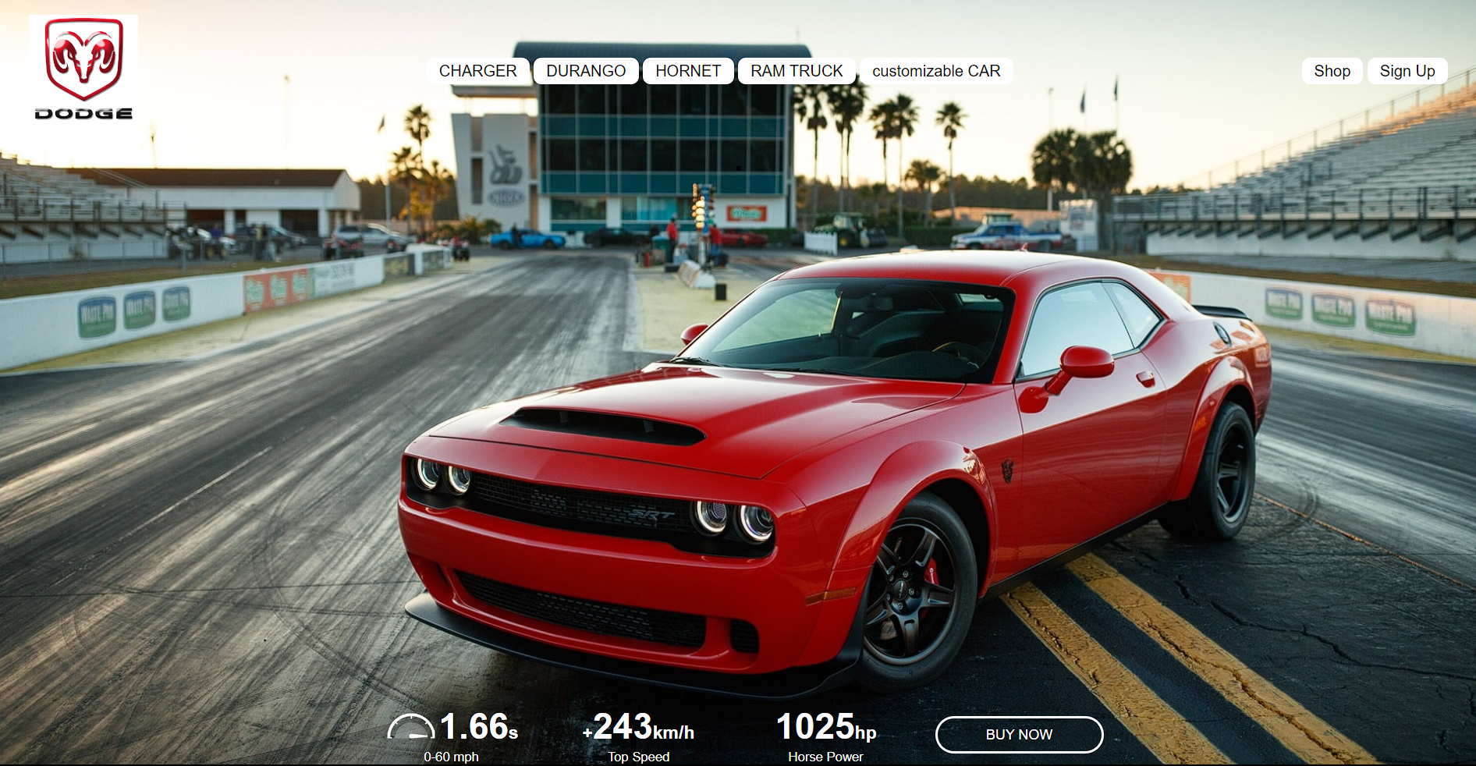

**MAIN PAGE**



**INTRO OF DODGE CHALLNGER SRT DEMON**

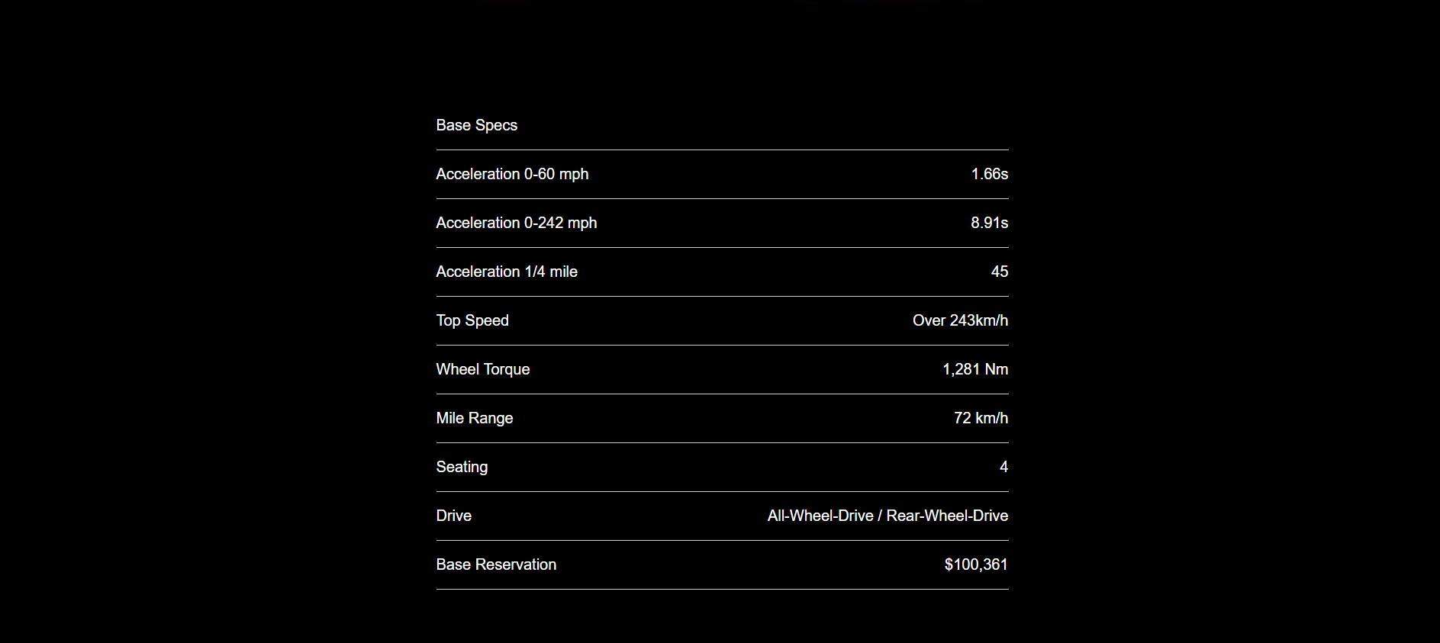

**BASIC SPECIFICATION**

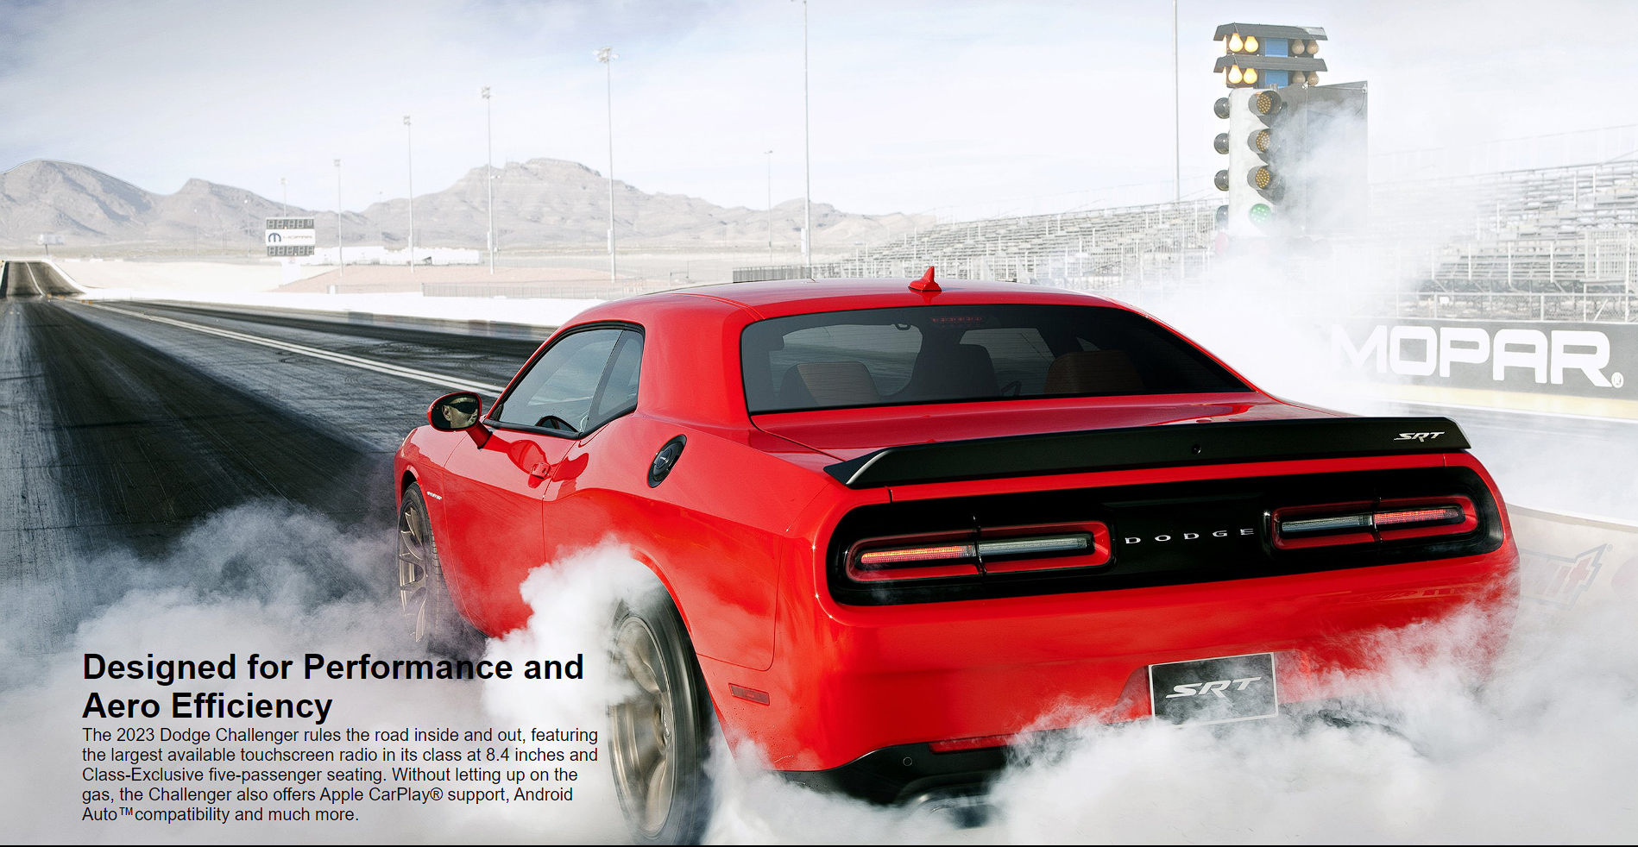

**DESIGEND FOR PERFROMANACE AND AERO EFFICIENCY**

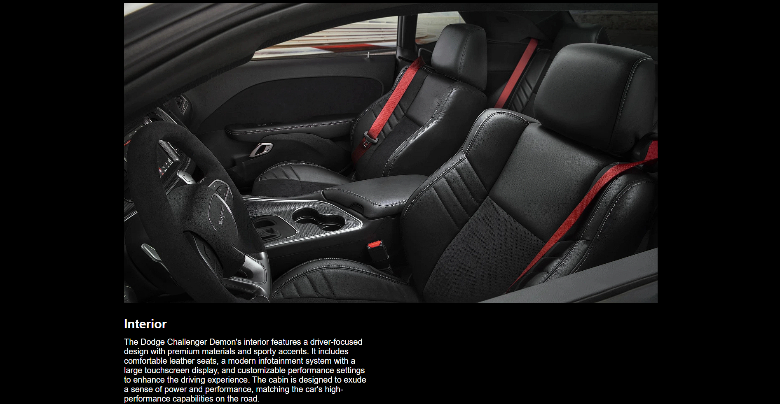

**INTERIOR**

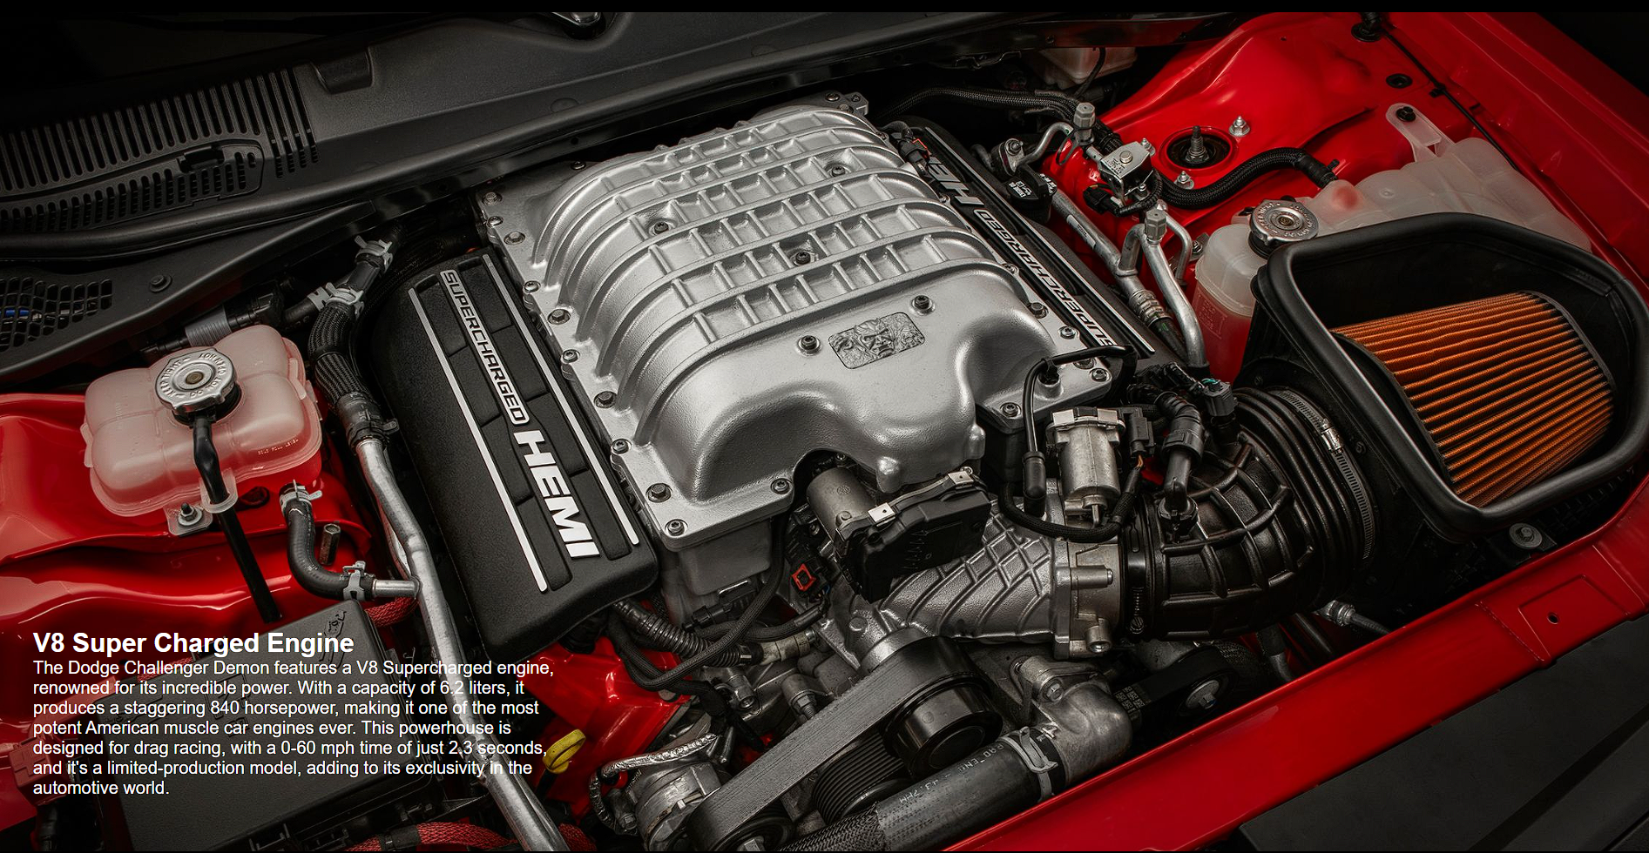

**V8 SUPER CHARGED ENGINE**

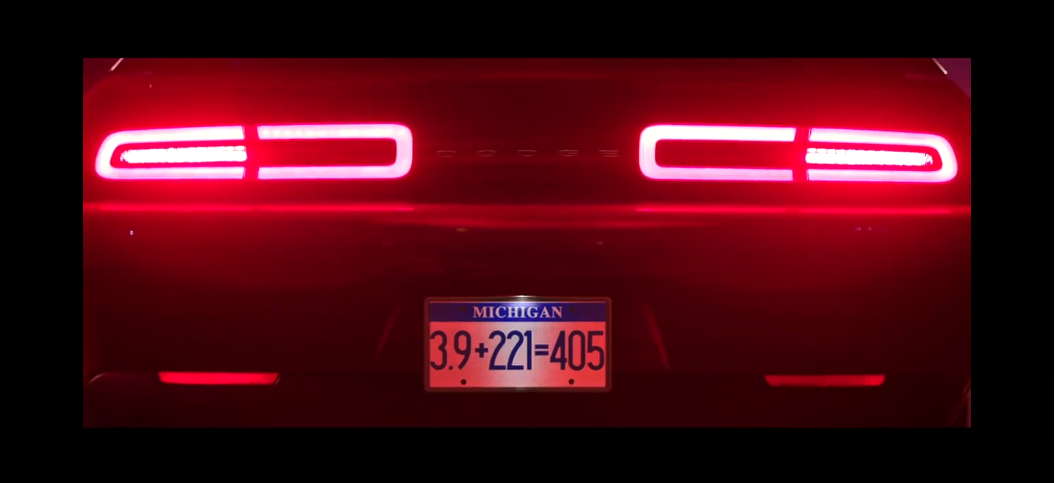

**Race video**



**FOOTER**

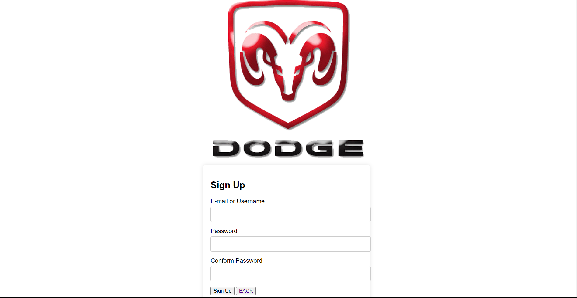

**SIGN UP PAGE**